CathPCI XML to PSV Conversion Project
Manabu Tokunaga
manabuBeach@gmail.com
Revised on: 9 January 2017 by Manabu
This document is preliminary and not all parts are completed nor approved.

Scope of Work

This is the scope of work proposal submitted to HealthLevel with respect a data conversion project.
The delivered product provides NCDR CathPCI submission data to be converted to HealhLevel’s Pipe Separated Value format data stream or file.

Client Deliverables
- A sufficient set of CathPCI submission file to test and validate
- Testing of the resulting outputs

Other Expectations
- Client to integrate the deliverables without affecting the development testing functionality (e.g., command line based test invoker).
- Deliverable to be serviceable without heavily integrated into the client’s architecture. For example, it gets so integrated with the databases, web UI’s to the point without building the entire product, the deliverable cannot be tested.

Deliverables

Inputs
CathPCI XML files

Output
A set of .psv (pipe separated values) file per format specified in this document
Pipe (|) characters will be escaped using standard escape sequence (\).
(\=\\, | = \|)

Included
- C# based API Class that provides the functionality to convert a single CathPCI submission file to Pipe Separated Value text streams. As text streams they can be stored in physical files or pile that into other medium such as Amazon S3 blob.
- For development and diagnostic purposes, a default “save to file” API will be provided as well as raw stream returns for piping to downstream processes. This can be invoked from a command line.
- Unit test functions using simple sample dataset.
- Logging facility configured with the .config file for the default location, overridable in the constructor. (See the API)

Not Included
- Interface to blob or other medium. That is the responsibility of the customer or an extension of a scope.
- Validation of field values. They are assumed to be correct, or another downstream process performs the validation.

Acceptance Criteria
To be filed by the customer.

PSV Schema
The Pipe Separated Values output file shall have the following characteristics;
- There are 7 known files (could increase or decrease in the final delivery). Each file represents the top XML level that contains multiple instance elements. For example, the episode level file contains all of the episode level data found in the XML.
- Each file has a single Info column which stays the same indicating the schema being represented in the rest of the columns.
- The first column of the file is named "StartLine" and the values in each row are the same "StartLine".
- For the First line which contains
  - The second column name is "Info" and the values indicate the type of information in that specific ROW.
  - Then followed by key field names (see the description in the table below)
  - All other column names are taken directly from the XML field names. See Field to Column mapping schemes.
Info Field: Describes the content, it start with CP. Then more detailed information to follow. All CP type file contains the schema version number (4.4) and NCDPatientID.
StartLine | This always is the first part of the line.
Info | File info string starts with CP then describes various CathPCI section levels to express multiple field sets.  - CP.PAT: for patient level information  - CP.PAT.EPI containing the Base Episode  - CP.PAT.EPI.VISIT: Visit level, including Disparage  - CP.PAT.EPI.VISIT.DICHMED discharge medications  - CP.PAT.EPI.VISIT.PCI.CM: PCI Closure Methods  - CP.PAT.EPI.VISIT.PCI.LES: PCI Lesions fields  - CP.PAT.EPI.VISIT.PCI.DEV: PCI Devices fields  - CP.PAT.EPI.VISIT.PCI.PROCMED: Procedure Medications
RegistryVersion | This is pulled from the submission file. E.g. 4.4
NCDRPatientID | All files contain the NCDR PatientID info.
ArrivalDate | For Episode level data and below, it contains ArrivalDate
ArrivalTime | For Episode level data and below, it contains ArrivalTime
ProcDate | For Visit level and below it contains the procedure date
ProcTime | For Visit level and below, it contains procedure time

- Each row shall have at least the patient Id and case number (cathlab visit id), in addition to other data fields.
- Within one file, each row will be the same number of columns (pipe delimiters)
- For purposes of this project, each file will contain only one type of "Info"
- All column names are preserved from the XML therefore, it is possible to reverse the operation and generate the XML. There should be no loss of data incurred forming the psv files.

Field to Column Mapping Schemes

- The first line of the file contains column names. Names are taken directly from the XML field names without <>
- Some fields have parent element (see the example below). In that case the column name shall have the parent name column. That column will always have the empty data field
  - Subfield will be prefixed with + to denote that it is a child column

Consider the following example,

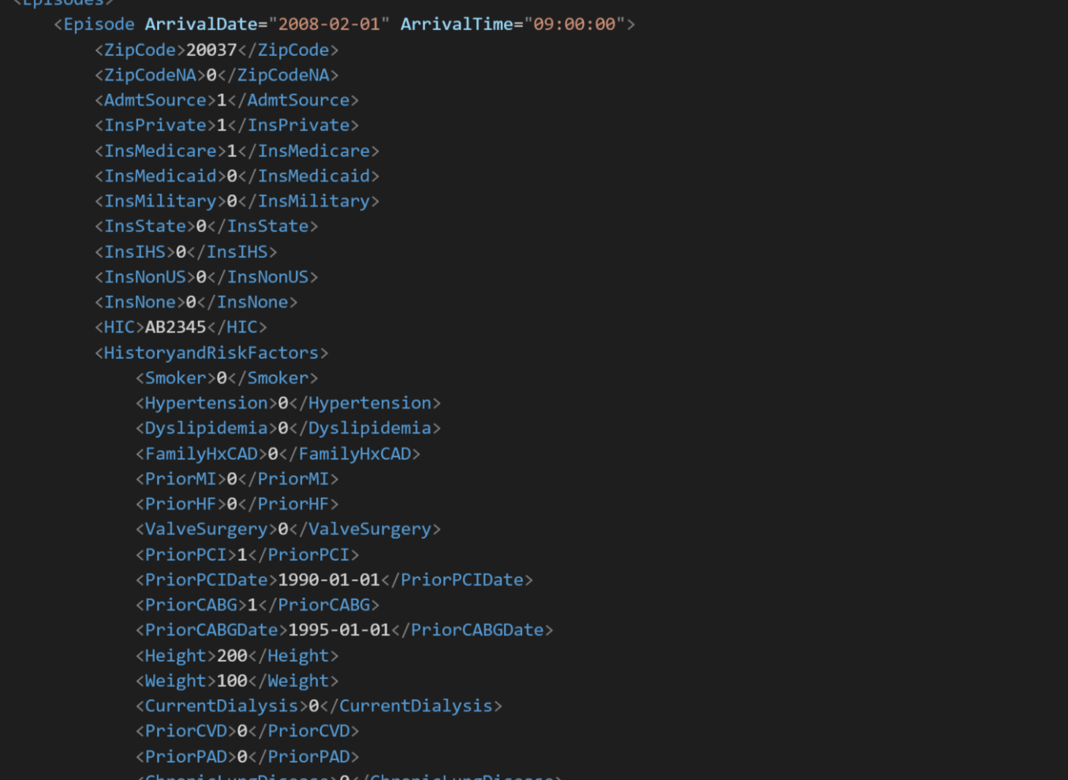
Will result in
|STARTLINE|CP.PAT.EPI|4.4|123456|2008-02-01|09:00:00|Episode|ZipCode|AdmSource|InsPrivate|InsMedicare|InsMedicaid|InsMilitary|IntIHS|InsNonUS|InsNone|HistoryAndRiskFactors|+Smoker|+Hypertension|… etc.

Output
- For each XML submission file shall create 6 files/streams
  - Naming convention is “root file name” specified in the XML file and it will suffix the last segment of schema.
  - Example,
    - If the submission file is specified as “Job123.xml” then the output file would be Job123.pat.psv, Job123.epi.psv, job123.cm.psv etc.
- Since each XML file can contain multiple patients and episodes, each file will contain the mixture of multiple patients and episodes keyed by PatientID, episode date/time and procedure date/time

Log Format

UTC Date/Time plus message type and the text message. Message type can be INFO, WARN, DEBUG, ERROR. Level may be adjusted.
05/14/2015 21:42:05.073: [INFO] Process started.

Appendix

API Interface

namespace SubmissionImporterPack
{
public class OutputResult
{
public enum ResultTypeEnum { Patients, Episodes, Visits, Closures, Lesions, Discharges}
public ResultTypeEnum ResultType;
public int ErrorCount;
public MemoryStream ResultStream;
}
public interface ISumbissionImporter
{
void TranslateToPsv(string pciSubmissionFileName, string baseOutputPath);
List<OutputResult> TranslateToPsv(MemoryStream submissionStream);
}
}

