xferUtility

Command to install the windows service: (Run cmd as admin)
C:\Windows\Microsoft.NET\Framework\v4.0.30319\InstallUtil.exe PathToExe(bin/debug/Foundations.xferUtility.exe)

Command to delete the windows service:
sc delete “ServiceName”

- Node monitor

Changes in App.config –

<add key="xferType" value="nodemonitor"/>
<add key="eventIntervalInMin" value="1" /> (value as required)
<add key="NodeName" value="QA"/> (value will appear in the email alert as shown below)
<add key="Drives" value="C,D,E"/> (comma separated drive names which are to be monitored or “*” to monitor all the drives)
<add key="RequiredFreeSpace" value="25"/> (in percent)
<add key="SmtpToEmailAddress" value="tanushree@healthlevel.com" />
An email alert will be sent to the specified address whenever any of the specified drive has free disk space lesser than the threshold.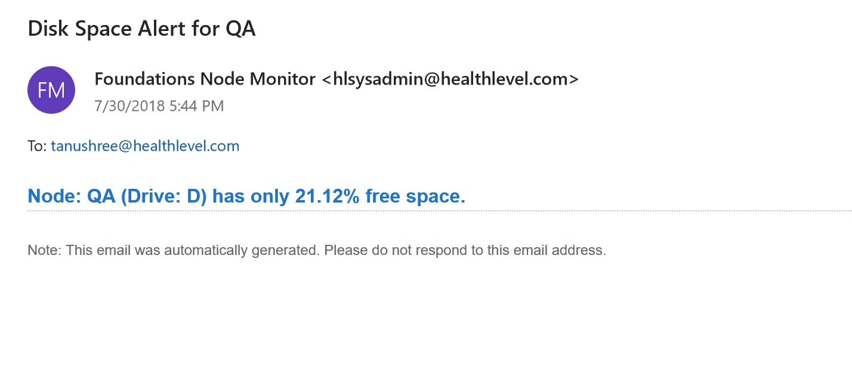

- Uploader

- Create a S3 bucket for customer (say hltokentest)
- Create IAM user for this customer, with below policy:
{
"Version": "2012-10-17",
"Statement": [
{
"Sid": "VisualEditor0",
"Effect": "Allow",
"Action": "sts:*",
"Resource": "*"
},
{
"Sid": "VisualEditor1",
"Effect": "Allow",
"Action": "s3:*",
"Resource": [
"arn:aws:s3:::hltokentest/*",
"arn:aws:s3:::hltokentest"
]
}
]
}

Add credentials for this IAM user to Web.config as below:
<add key="AWSAccessKey" value=" "/>
<add key="AWSSecretKey" value=" "/>

- Changes in App.config :
<add key="xferType" value="upload"/>
<add key="eventIntervalInMin" value="1" /> (value as required)
<add key="AppCustomerGuid" value="b150d01d-40ab-46d5-a367-825ab01321fb"/>
<add key="listenerGuid" value="hltest"/>
<add key="uploadToCloud" value="true" />
(uploaded to cloud or on premise depending on this flag)
<add key="AppSyncedFolder" value="synced"/>
<add key="AppNotSyncedFolder" value="not-synced"/>
For location of files to be uploaded ->
<add key="forcesourceFolder" value="False" />
<add key="forcesourceFolderPath" value="D:\Foundationsshare" />
<add key="UploaddataFolder" value="C:\uploader-hltest\" />
(If forcesourceFolder is true, files in the forcesourceFolderPath will be uploaded.
Else this will create path- “C:\uploader-hltest\listener-hltest\extractor\data” and files in this location will be uploaded.)
hlRunConfig.xml :
<?xml version="1.0" encoding="utf-8"?>
<config>
<authentication accessKeyId=" " secretAccessKey="" sessionToken="" expiresOn="" bucketName=""></authentication>
<listener type="PSV" guid="hltest" lastFileCheckedOn=""></listener>
</config>

If authtoken is valid, it will take the credentials from this config file, else TokenVendor service will be called to generate token.

Data will be encrypted if crypto(From Listener table) is true. If DeleteafterUpload(in Web.config) is set to false, zipped files will be moved to C:\uploader-hltest\listener-hltest\uploader\data\uploaded, else they will be deleted.
(Add below key to Web.config - <add key="DeleteafterUpload" value=""/>)

For upload on cloud ->
- Files from C:\uploader-hltest\listener-hltest\extractor\data will be zipped and added to C:\uploader-hltest\listener-hltest\uploader\data\zipped
- The files in zipped folder will be uploaded to the bucket specified ( BucketName in Customer table), on the path listener-hltest/data/not-synced
- If DeleteafterUpload is true, the files will get deleted from zipped folder
Else, the files will be moved to C:\uploader-hltest\listener-hltest\uploader\data\uploaded

For upload on premise ->
- Files from C:\uploader-hltest\listener-hltest\extractor\data will be zipped and added to C:\uploader-hltest\listener-hltest\uploader\data\zipped
- The files in zipped folder will be uploaded to the LoadFileDownloadPath\downloader\data
(LoadFileDownloadPath obtained from DataLoadListenerProgram table)
- The files will be moved to C:\uploader-hltest\listener-hltest\uploader\data\uploaded

- Downloader

Changes in App.config :
<add key="xferType" value="download"/>
<add key="eventIntervalInMin" value="1" /> (value as required)
<add key="AppCustomerGuid" value="b150d01d-40ab-46d5-a367-825ab01321fb"/>

<add key="AppCustomersDatabaseName" value="HLCustomer"/>
<add key="AppLoadDatabaseName" value="HLLoad"/>
<add key="AppSyncedFolder" value="synced"/>
<add key="AppNotSyncedFolder" value="not-synced"/>

- Download zipped files from Bucketname/listener-hltest/data/not-synced to LoadFileDownloadPath/downloader/data
- Extract files from LoadFileDownloadPath/downloader/data to LoadFileSourcePath
- Move files from Bucketname/listener-hltest/data/not-synced to Bucketname/listener-hltest/data/synced on cloud
(LoadFileDownloadPath and LoadFileSourcePath obtained from DataLoadListenerProgram table)

